Adapter Pattern

Structural Design Pattern

**What is Adapter:**

1. We have an existing object which provides the functionality that the client needs. But client code can’t use this object because it expects an object with a different interface.
2. Using the Adapter design pattern we make this existing object work with the client by adapting the object to the client's expected interface.
3. Also called a wrapper.

**UML:**

Class Adapter:

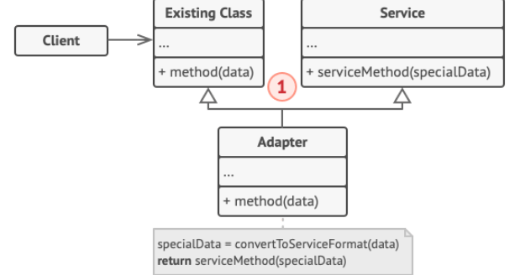

1. Adaptee - provides the functionality, which is needed by the client
2. Target - the interface expected by the client. Has method operation
3. Adapter - solves the problem; a class that extends from our existing class, which provides the functionality and implements the target interface which is expected by the client. Has method operation which calls the functionality in the Adaptee.

Object Adapter:

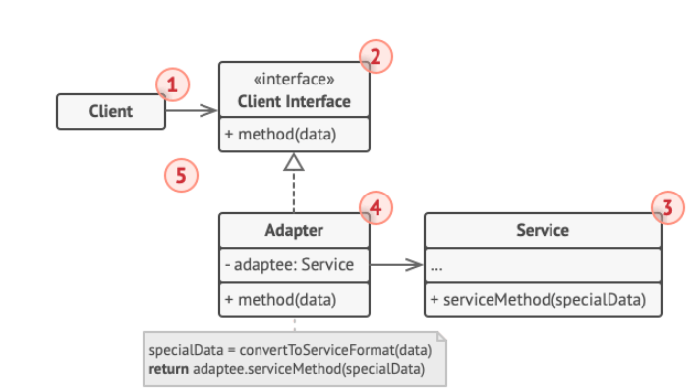

1. Adaptee - our existing class providing the needed functionality.
2. Target - interface expected by the client.
3. ObjectAdapter - implement the target interface and we have an inner object Adaptee.

**Difference between Class and Object Adapter:**

1. Object Adapter uses composition
2. Class Adapter uses inheritance
3. Object Adapter is preferred.